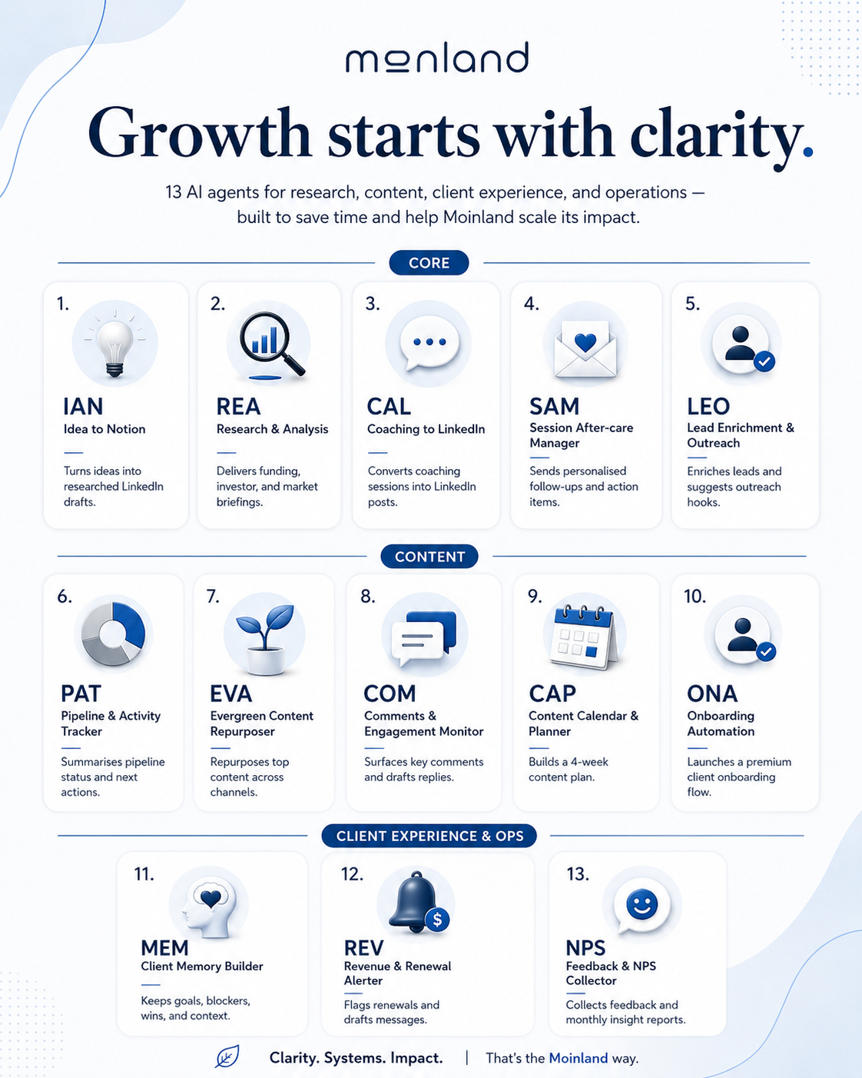

Moinland AI Agent Ecosystem
May 2026

Overview
This document captures the full Moinland AI Agent Ecosystem — ten N8N automation agents designed to save Daniel Kraft time on research, content creation, client management, and operations. Three agents are live. Seven are ready to build. Each agent follows the same naming convention: a three-letter code, a descriptive name, and a use case in the format 'As a [role], I want to [action] so that [outcome].'
Tier | Category | Agents | Status
1 | Core (built + quick wins) | IAN · REA · CAL · SAM · LEO · PAT | IAN, REA, CAL live.  SAM, LEO, PAT ready to build.
2 | Content & thought leadership | EVA · COM · CAP | Not built. Build after Tier 1 is stable.
3 | Client experience & ops | ONA · MEM · REV · NPS | Not built. Most powerful when MEM is live.

Tier 1A — Agents Already Built
IAN — Idea to Notion | 1 — Built | Live
Use case | As a CEO, I want to send a topic idea via Telegram and receive a fully researched LinkedIn post draft saved to my Notion pipeline so that I spend less time writing and more time coaching.
Trigger | Telegram message (topic text)
Tech stack | Telegram · OpenAI GPT-4o-mini · Tavily · Notion
Credentials | Telegram account 2 · OpenAI account 2 · Tavily account · Notion account
Output | Notion Blogpost Pipeline database
Notes | Error handling: Error Trigger → Telegram alert with node name and timestamp. Retries on Research and Create nodes (maxTries: 2).
Workflow steps | 1 Telegram Listener receives topic from Daniel  2 Acknowledgement sent back to Telegram  3 Brand Voice fetched from Notion Knowledge Base  4 GPT-4o builds a structured content brief with web search  5 Example Posts fetched from Notion Knowledge Base  6 GPT-4o writes LinkedIn post in Daniel's voice  7 Draft saved to Notion Blogpost Pipeline (Status: Draft)  8 Notion URL sent to Daniel via Telegram

REA — Research & Analysis | 1 — Built | Live
Use case | As a CEO, I want to get regular updates on funding trends, investments, and news from investors so that I spend less time researching and more time on conversations with clients.
Trigger | Schedule trigger — daily 06:00 (RSS ingestion) + weekly Monday 07:00 (briefing send)
Tech stack | N8N Schedule Trigger · RSS Feed · OpenAI Embeddings · Pinecone · GPT-4o-mini · SMTP Ionos
Credentials | OpenAI account 2 · Pinecone Moinland · SMTP Ionos
Output | Email via SMTP Ionos (briefing@vonaschoff.de → markus@vonaschoff.de)
Notes | Pinecone index: moinland-briefing. Error handling on all critical nodes: continueOnFail + retryOnFail (3x, 5s). Separate alert emails for RSS failure, Pinecone failure, and weekly briefing failure.
Workflow steps | 1 Daily: 4 DACH startup RSS feeds fetched (Sifted, deutsche-startups.de, EU-Startups, Silicon Canals)  2 Failed feeds filtered and logged; all-feeds-failed alert sent via SMTP  3 Articles normalised (fallback values for missing fields)  4 Chunks embedded via OpenAI and stored in Pinecone (moinland-briefing, namespace: funding-news)  5 Weekly: AI Agent queries Pinecone for past 7 days of news  6 GPT-4o-mini writes 4-section briefing (Big rounds / Investor moves / Market signal / Founder pulse)  7 Markdown converted to HTML; sent via SMTP Ionos to markus@vonaschoff.de  8 Fatal errors trigger SMTP alert emails

CAL — Coaching to LinkedIn | 1 — Built | Live (v2)
Use case | As a CEO, I want to turn valuable conversations and topics from coaching sessions into a LinkedIn post draft that is well researched, has data points, and feels like it comes from me so that I spend less time writing and more time coaching.
Trigger | Google Drive Trigger — new file in 'Granola Sessions' folder
Tech stack | Google Drive · OpenAI Embeddings · Pinecone · GPT-4o-mini Agent · Tavily · Notion · Telegram
Credentials | Google Drive Moinland · OpenAI account 2 · Pinecone Moinland · Tavily account · Notion account · Telegram account 2
Output | Notion Blogpost Pipeline + Telegram notification
Notes | Pinecone index: moinland-coaching. Known issues resolved: (1) Drive download requires Extract From File node before Extract Session Text; (2) Identify Best LinkedIn Topic must use Agent node not OpenAI node — tool schema mismatch otherwise; (3) Guard and Parse nodes must not reference ancestor nodes via $('node name') inside Code sandbox — use $input.first() only.
Workflow steps | 1 Granola exports session note as .md to Google Drive 'Granola Sessions' folder  2 Drive Trigger detects new file; downloads it  3 Extract From File (Text) converts binary to plain text  4 Extract Session Text Code node parses title, body, date, attendees  5 Telegram acknowledgement sent to Daniel  6 Session normalised and stored in Pinecone (moinland-coaching, coaching-sessions namespace)  7 AI Agent (GPT-4o-mini) queries Pinecone to identify the single strongest LinkedIn topic  8 Parse Topic JSON Code node validates and extracts: topic, angle, searchQuery, targetEmotion, whyNow  9 Brand Voice + Example Posts fetched from Notion Knowledge Base  10 Research and Content Brief node (GPT-4o-mini + Tavily web search) generates structured brief  11 Create LinkedIn Post node (GPT-4o-mini) writes full post in Daniel's voice  12 Guard: Empty Post Output validates result (>30 chars)  13 Draft saved to Notion Blogpost Pipeline (title: session + topic, Status: Draft)  14 Notion URL sent to Daniel via Telegram

Tier 1B — Recommended Quick Wins

SAM — Session After-care Manager | 1 — Recommended (Quick win) | Not built
Use case | As a coach, I want to automatically send a personalised follow-up summary after every coaching session so that clients feel seen, have their action items in writing, and I spend zero time writing recap emails.
Trigger | Google Drive Trigger — same 'Granola Sessions' folder as CAL (or CAL output trigger)
Tech stack | Google Drive · OpenAI GPT-4o · Notion CRM · Gmail / SMTP Ionos · Telegram
Credentials | Google Drive Moinland · OpenAI account 2 · Notion account · SMTP Ionos
Output | Client email + Notion client page
Notes | Can be triggered as a sub-workflow from CAL to avoid duplicate Drive polling. Requires Notion CRM database with client email and name fields.
Workflow steps | 1 Session note detected in Google Drive (reuses CAL trigger)  2 Extract session text (reuse CAL Extract Session Text node)  3 GPT-4o generates personalised summary: key themes, 3 action items, open questions  4 Client email address looked up from Notion CRM (match by session title / attendee name)  5 Personalised recap email sent via Gmail / SMTP  6 Notion client page updated with session summary and date

LEO — Lead Enrichment & Outreach | 1 — Recommended (Quick win) | Not built
Use case | As a CEO, I want to automatically enrich new leads from my CRM with LinkedIn data, company stage, and funding history so that I walk into every intro call already knowing who I'm talking to.
Trigger | Notion CRM trigger — new lead added (Status: New Lead)
Tech stack | Notion CRM · Tavily · OpenAI GPT-4o · Telegram · Gmail
Credentials | Notion account · Tavily account · OpenAI account 2 · Telegram account 2
Output | Notion CRM lead page + Telegram notification
Notes | Consider Apollo.io API for richer B2B data. Tavily free tier may rate-limit at high lead volumes.
Workflow steps | 1 New lead detected in Notion CRM database  2 Tavily searches for: LinkedIn profile, company funding history, recent news  3 GPT-4o compiles enrichment summary: background, stage, recent challenges, conversation hooks  4 Notion lead page updated with enrichment data  5 Telegram alert sent to Daniel with summary and suggested opener  6 Optional: draft outreach email generated and saved as draft in Gmail

PAT — Pipeline & Activity Tracker | 1 — Recommended (Quick win) | Not built
Use case | As a CEO, I want a weekly summary of my sales pipeline — new leads, stalled deals, and next actions — sent to me every Monday morning so that I never lose track of where conversations stand without opening my CRM.
Trigger | Schedule Trigger — Monday 07:30 Europe/Berlin (after REA briefing)
Tech stack | Notion CRM · OpenAI GPT-4o · SMTP Ionos / Telegram
Credentials | Notion account · OpenAI account 2 · SMTP Ionos or Telegram account 2
Output | Email + Telegram
Notes | Define 'stalled' threshold in the Code node (currently suggested: 14 days since last_updated). Requires consistent use of Notion CRM status field.
Workflow steps | 1 Query Notion CRM for all active deals (filter: Status not Closed/Lost)  2 Categorise by stage: New Lead, In Conversation, Proposal Sent, Stalled (>14 days no update)  3 GPT-4o writes pipeline summary: deals by stage, stalled flag, suggested next actions per deal  4 Summary sent via SMTP / Telegram  5 Optional: Notion weekly pipeline snapshot page created for tracking over time

Tier 2 — Content & Thought Leadership

EVA — Evergreen Content Repurposer | 2 — Content | Not built
Use case | As a CEO, I want my best-performing LinkedIn posts automatically repurposed into newsletter sections, blog intros, and Twitter/X threads so that one great idea reaches every channel without extra writing time.
Trigger | Manual trigger or weekly schedule — queries Notion Blogpost Pipeline for posts with Status: Published
Tech stack | Notion · OpenAI GPT-4o · Telegram
Credentials | Notion account · OpenAI account 2 · Telegram account 2
Output | Notion Blogpost Pipeline (new repurposed pages)
Notes | Can connect to Ghost/Substack API for direct newsletter publishing. Twitter/X API requires paid developer account.
Workflow steps | 1 Fetch published posts from Notion Blogpost Pipeline (last 30 days)  2 GPT-4o scores each post for repurposing potential (engagement signals, depth, evergreen value)  3 Top 2 posts selected for repurposing  4 GPT-4o generates: newsletter paragraph, blog intro (300 words), Twitter/X thread (5 tweets)  5 Repurposed content saved to Notion with format tags  6 Telegram notification with Notion links

COM — Comments & Engagement Monitor | 2 — Content | Not built
Use case | As a CEO, I want to be alerted to high-value comments on my LinkedIn posts and get a suggested reply drafted in my voice so that I engage meaningfully without spending time monitoring notifications.
Trigger | Schedule Trigger — every 4 hours (polls LinkedIn via third-party tool)
Tech stack | LinkedIn API / Phantombuster · OpenAI GPT-4o · Telegram
Credentials | LinkedIn API or Phantombuster account · OpenAI account 2 · Telegram account 2
Output | Telegram (for review) + LinkedIn (on approval)
Notes | Most technically complex of the 10 agents. LinkedIn official API does not expose comment reads without partner access — Phantombuster ($59/mo) or RapidAPI LinkedIn scraper are the practical paths. Build after all Tier 1 agents are stable.
Workflow steps | 1 Fetch recent comments via LinkedIn API or Phantombuster / RapidAPI LinkedIn scraper  2 Filter for high-value comments (length >50 chars, question or insight signal)  3 GPT-4o drafts a reply in Daniel's brand voice for each shortlisted comment  4 Telegram alert with original comment + suggested reply  5 Daniel approves or edits reply in Telegram; confirmed reply posted via LinkedIn

CAP — Content Calendar & Planner | 2 — Content | Not built
Use case | As a CEO, I want an AI-generated 4-week LinkedIn content plan based on my coaching themes, market signals from REA, and my past post performance so that I always have a clear posting strategy without planning sessions.
Trigger | Manual trigger (Telegram command 'plan') or monthly Schedule Trigger
Tech stack | Pinecone · Notion · OpenAI GPT-4o · Telegram
Credentials | Pinecone Moinland · Notion account · OpenAI account 2 · Telegram account 2
Output | Notion content calendar page + Telegram
Notes | Depends on CAL being live and accumulating sessions in Pinecone. More valuable after 10+ sessions are stored. CAP feeds IAN — use CAP topics as IAN inputs.
Workflow steps | 1 Query Pinecone coaching sessions (moinland-coaching) for recurring themes of past 30 days  2 Fetch last REA briefing from Notion or Pinecone for market signals  3 Fetch published posts from Notion to identify gaps and avoid repetition  4 GPT-4o generates a 4-week content plan: one post per week, with topic, angle, hook direction, and best posting day  5 Plan saved as structured Notion page in Blogpost Pipeline  6 Telegram notification with plan summary

Tier 3 — Client Experience & Operations
ONA — Onboarding Automation | 3 — Operations | Not built
Use case | As a CEO, I want new coaching clients to automatically receive a personalised onboarding sequence — welcome email, intake form, first session prep doc — the moment they sign in Notion so that every client starts with a premium experience and I do not manage logistics manually.
Trigger | Notion CRM trigger — Status changed to 'Active Client'
Tech stack | Notion CRM · OpenAI GPT-4o · Gmail · Typeform/Tally · Calendly API · Telegram
Credentials | Notion account · OpenAI account 2 · Gmail OAuth · Telegram account 2
Output | Client inbox + Notion client page
Notes | Requires Notion CRM to have consistent fields: client name, company, goals, email. Calendly API integration is optional — a static link in the email works as a simpler first version.
Workflow steps | 1 New active client detected in Notion CRM  2 GPT-4o generates personalised welcome email (name, company, coaching goals from CRM)  3 Welcome email sent via Gmail  4 Intake form link included (Typeform or Tally)  5 Calendly link for first session included  6 First session prep document generated and saved to Notion client page  7 Internal Telegram notification to Daniel

MEM — Client Memory Builder | 3 — Operations | Not built
Use case | As a coach, I want every coaching session automatically indexed into a per-client memory in Pinecone — goals, blockers, wins, open threads — so that I walk into every session with instant context and never ask a client to repeat themselves.
Trigger | Google Drive Trigger — same 'Granola Sessions' folder as CAL (can be sub-workflow of CAL)
Tech stack | Google Drive · OpenAI GPT-4o + Embeddings · Pinecone (per-client namespaces) · Notion
Credentials | Google Drive Moinland · OpenAI account 2 · Pinecone Moinland · Notion account
Output | Pinecone moinland-coaching (per-client namespace) + Notion client page
Notes | Namespace convention: 'client-{slug}' (e.g. client-muster-gmbh). Requires client name or company to be extractable from the Granola session title. This agent makes CAL, SAM, REV, and CAP all significantly more powerful.
Workflow steps | 1 Session note detected and text extracted (reuse CAL pipeline)  2 GPT-4o extracts structured memory: goals discussed, blockers, wins, open threads, follow-ups  3 Memory upserted to Pinecone under per-client namespace (e.g. 'client-acme-gmbh')  4 Notion client page updated with session snapshot  5 On next session trigger: previous memory retrieved and included in session context prompt

REV — Revenue & Renewal Alerter | 3 — Operations | Not built
Use case | As a CEO, I want to be automatically alerted 30 and 14 days before a client contract renewal — with their session history, NPS, and a suggested renewal message drafted — so that I never miss a renewal conversation and always come prepared.
Trigger | Schedule Trigger — daily 08:00, queries Notion CRM for upcoming renewals
Tech stack | Notion CRM · Pinecone (client namespaces) · OpenAI GPT-4o · Telegram · Gmail
Credentials | Notion account · Pinecone Moinland · OpenAI account 2 · Telegram account 2 · Gmail OAuth
Output | Telegram alert + Gmail draft
Notes | Requires Notion CRM to have contract_end_date field. Most effective when MEM is live — client memory makes the renewal summary much richer. Pair with NPS agent for full picture.
Workflow steps | 1 Query Notion CRM for clients with contract_end_date in 30 or 14 days  2 For each: query Pinecone client memory for session themes and progress  3 Fetch NPS score from Notion (if NPS agent is live)  4 GPT-4o generates: renewal preparation summary + suggested renewal message in Daniel's voice  5 Telegram alert with all context and suggested message  6 Draft renewal email saved in Gmail drafts for review

NPS — Feedback & NPS Collector | 3 — Operations | Not built
Use case | As a CEO, I want to automatically send a short feedback request after every coaching session and aggregate NPS scores and themes into a monthly insight report so that I have a continuous pulse on client satisfaction without manual follow-up.
Trigger | Google Drive Trigger — new session in Granola Sessions folder
Tech stack | Google Drive · Typeform/Tally · Notion · OpenAI GPT-4o · Gmail
Credentials | Google Drive Moinland · Typeform or Tally account · Notion account · OpenAI account 2 · Gmail OAuth
Output | Notion NPS database + monthly email report
Notes | 24-hour delay requires N8N Wait node after session trigger. Typeform free tier allows up to 10 responses/month — Tally is free and unlimited for basic forms. NPS data feeds REV agent for renewal prep.
Workflow steps | 1 New session detected (reuse CAL trigger)  2 24 hours after session: feedback email sent to client (Typeform or Tally NPS form link)  3 Form responses collected in Typeform/Tally and pushed to Notion via webhook  4 Monthly: GPT-4o aggregates all NPS scores and open text responses  5 Themes extracted (what's working, blockers, suggestions)  6 Monthly NPS insight report saved to Notion + sent to Daniel via email

Handover — Continuing the Build

This section is designed to give any developer, assistant, or future Claude session full context to pick up exactly where the build left off — with no rework and no repeated questions.

Infrastructure already in place
- N8N instance: self-hosted. Workflows active: IAN (PhkfVRRwB5Bq0GLF), REA (GEjHpvC6saBcTgWy), CAL (CAL-coaching-to-linkedin-v2).
- Pinecone: two live indexes — moinland-briefing (funding news, namespace: funding-news) and moinland-coaching (coaching sessions, namespace: coaching-sessions). Credential ID: e1V3KLu5uUsncikF.
- OpenAI: account 2 connected, model: gpt-4o-mini for all current agents. Credential ID: MvDgIolFQ0CkZy93.
- Notion: Moinland Knowledge Base (361641dc-4875-80fa-9908-c2a15b84d136) contains Brand Voice and Example Posts (Type filter). Blogpost Pipeline database (35f641dc48758087a744fcb84e915175) receives all post drafts.
- Telegram: account 2 (JoAeGUPLgB1pu101). Chat ID for Daniel alerts: 8452712398.
- SMTP: Ionos (imtJEXYdBnD17Brk). From: briefing@vonaschoff.de. To: markus@vonaschoff.de.
- Tavily: account WJkd68ezdwHSRgDA. Used for web search in IAN and CAL.
- Google Drive: 'Granola Sessions' folder watches for new .md files from Granola.ai. Credential ID: REPLACE_WITH_YOUR_GDRIVE_CREDENTIAL_ID (not yet finalised).

Known issues and fixes applied
- CAL: Google Drive download node must NOT use googleFileConversion for .md files. Add Extract From File (Text) node between Download and Extract Session Text.
- CAL: Extract Session Text Code node must read from $input.first().json.data — not from binary or $('node').item references. Full corrected code is available in conversation history.
- CAL: Identify Best LinkedIn Topic must use the Agent node (@n8n/n8n-nodes-langchain.agent), NOT the OpenAI completion node. Tool schema mismatch occurs otherwise.
- CAL: Parse Topic JSON and Guard — Empty Post Output Code nodes must use $input.first() only. Referencing $('Extract Session Text') or $('Parse Topic JSON') inside the Code sandbox throws 'Unknown error' at throwExecutionError.
- REA: RSS feeds return 'Invalid attribute name' XML errors on Sifted and Startuprad.io. Fix: onError: continueRegularOutput + ignoreSSL: true on RSS node, plus Filter Failed Feeds Code node.
- All Code nodes: $('node name') references are only safe in expression fields (Set node, Notion node parameters). Inside the Code node JS sandbox, always use $input or $('node') with try/catch.

Recommended build order for next session
- 1. SAM (Session After-care Manager) — easiest next build. Reuses the Granola → Drive pipeline from CAL. New: GPT-4o recap prompt + Gmail send. Estimated build time: 1 hour.
- 2. MEM (Client Memory Builder) — can be a sub-workflow of CAL. Adds per-client Pinecone namespaces. Makes REV, CAP, and SAM significantly more powerful. Estimated build time: 1.5 hours.
- 3. PAT (Pipeline & Activity Tracker) — standalone Monday morning workflow. Queries Notion CRM. Requires CRM database to have consistent Status and last_updated fields. Estimated build time: 1 hour.
- 4. LEO (Lead Enrichment & Outreach) — triggered by new Notion CRM entry. Requires Tavily (already connected) for LinkedIn and news search. Estimated build time: 1.5 hours.
- 5. ONA (Onboarding Automation) — triggered by client Status change in Notion. Requires Calendly API setup and Typeform/Tally account. Estimated build time: 2 hours.
- 6. REV (Revenue & Renewal Alerter) — depends on MEM being live for client context. Requires contract_end_date field in Notion CRM. Estimated build time: 1 hour.
- 7. CAP + EVA + NPS + COM — build after all Tier 1 and 2 agents are stable.

Shared prompt patterns worth reusing
- Brand voice injection: always fetch from Notion Knowledge Base (Type = Brand Voice) and pass as $('Get Brand Voice').item.json.property_content in the OpenAI system message.
- Example post injection: fetch from Notion (Type = Example Post, limit 1) and pass as $json.property_content in the user message for style calibration.
- Structured JSON output from agents: always add 'Return ONLY valid JSON. No markdown, no commentary.' to the system message. Validate in a downstream Code node with JSON.parse inside try/catch and a safe fallback object.
- Guard pattern: always add a Code node after any AI generation step. Validate output length > 30 chars. Use $input.first() only. Throw with a descriptive error message including session/context identifiers.
- Error alerting: connect all node error outputs (onError: continueErrorOutput) to a Telegram node with chat ID 8452712398. Include: error message, node name, timestamp, and relevant context (session title, file ID).

Conversation history reference
- The complete workflow JSON files for IAN, REA v2, and CAL v2 are available as downloadable outputs in this Claude project conversation.
- Brand voice guidelines are available as moinland_brand_voice_guidelines.md and .txt in the project outputs.
- Top 5 Daniel Kraft posts are compiled in daniel_kraft_top5_posts.txt in the project outputs.
- All N8N source workflow JSONs are in /mnt/user-data/uploads/ within the project.
- To resume: open a new Claude session in this project, reference this document, and start with 'Continue building the Moinland agent ecosystem — next agent is SAM'.

Moinland AI Agent Ecosystem | Confidential | Built with Claude + N8N | May 2026

